HANDS-ON STEM SUMMER CAMP

STUDENT AND TEACHER ENGAGEMENT

- Real-world challenges build empathy, persistence and confidence
- Authentic STEM experiences strengthen critical thinking and creativity
- High-energy activities keep students active, engaged and learning
- Innovative, ready-to-use strategies that are transferable to the classroom

TURNKEY IMPLEMENTATION

SPARK STEM CONFIDENCE
For more than 35 years, educators have turned to Camp Invention® to help meet their goals of inspiring curiosity, strengthening problem-solving skills and keeping students engaged in meaningful learning. This nationally recognized K–6 summer program provides ready-to-use, hands-on experiences that complement school priorities and reduce the burden on teachers. Each year’s new curriculum delivers high-energy, standards-based learning that supports skill development and long-term impact — backed by research and designed to fit your district’s vision for success.
- Save time with ready-to-use curriculum and materials
- Eliminate hassle with classroom sets shipped to your site
- Get the support you need for a smooth program
- Reduce prep with step-by-step guides and online tools

IMMERSIVE & FLEXIBLE CURRICULUM

- Four all-new, themed modules with eight hours of hands-on activities in each
- Aligned to NGSS and state science standards
- Evidence-based programs that support existing core math and ELA curricula through applied STEM Learning


LEARN MORE TODAY AT INVENT.ORG/EDUCATORS/CAMP-INVENTION
© 2025 National Inventors Hall of Fame®, Inc.

- Campers explore waves, buoyancy and surface tension through hands-on water experiments and learn the process of how to create and commercialize inventions.
- After diving into research, students apply customer feedback to improve their invention prototypes and design an eye-catching logo for their company.
- Campers analyze advertisements as inspiration for developing their own billboard boats that glide through the water and help them “make waves” in the market.
- Campers launch a mission to transform a new planet for human habitation using cutting-edge space innovations like rockets, telescopes and satellites.
- After gathering samples from their planet, campers create a Space Lab where they can evaluate the specimens, record scientific observations and brainstorm inventions.
- Campers build a DIY Space Rocket to experiment with launch angles and trajectory, work to keep a satellite in orbit and stretch their imagination while extending the frontier!
- Campers use their invention superpowers – the I Can Invent® Mindset – to solve challenges in their community with the power of intellectual property.
- Campers brainstorm, design and miniaturize a top-secret invention while discovering how
technology has enabled inventions to become smaller over time.
- Campers create wearable devices using cryptography, and race to file a patent to protect their inventions from invention-stealing Infringers.
  - Investigating a series of critter crimes, campers sharpen their detective skills as they collect evidence and discover how investigators use forensic science to solve crimes.
  - Campers explore inner mechanics of their robotic capybara sidekick and use creative problem solving to design sleuthing gadgets to support their investigation.
  - Practicing critical thinking and persistence, campers collect evidence, conduct interrogations, and explore DNA to solve the “who” and “how” behind the animal antics.

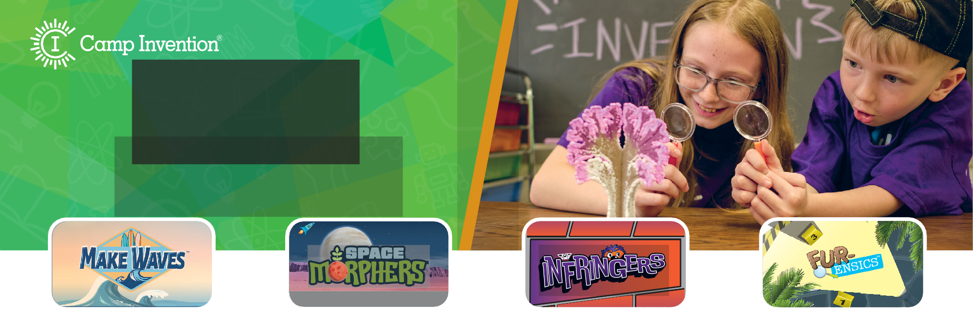
-NEWADVENTURES

Discover how Camp Invention can transform learning in your district through innovative, hands-on STEM experiences for K–6 students. This evidence-based approach aligns to standards and typically runs for one week but can be adapted to meet district needs.
™
ATTENTION!
INCOMING TRANSMISSION

