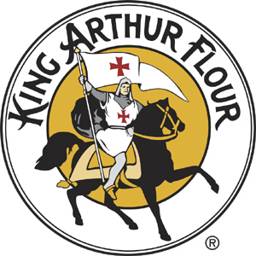

King Arthur Flour
Tooky Cookie Bake-off!
July 4, 2025
Hopkinton, New Hampshire

Official Rules and Entry Form

Tooky Cookie Bake-off Prizes:

Prizes will be awarded to 1st place, 2nd place, and 3rd place in both the adult and youth (12 and under) category.

Rules:

- Entry form is required (see below). Form must accompany cookies when submitted for contest.

- Exhibitor must use King Arthur Flour and bring the open bag or submit a UPC label from the flour bag when he/she submits the entry.

- Entry may be of any type of cookie (chocolate chip, oatmeal raisin, peanut butter, etc.)

- Exhibitor must provide at least one dozen cookies to qualify for the contest.

- Only one entry per person, but all family members are welcome to enter. We shall limit the number of entries to 100.

- Judging will be based on the following criteria:
  - Flavor 50 points
  - Overall Appearance 25 points
  - Minimal Crumble Effect (holds together) 20 points
  - Patriotic theme 5points
TOTAL 100 points

- Failure to follow the rules may result in disqualification.

-----------------------------------------------please return this form with your entry--------------------------------------------

Registration:

Cookies must be dropped off at the Contoocook Riverway Park at the Cookie Tent between 9:30 am- 11 am on July 4^{th.} All entries must be identified with the entry form and presented in an air-tight container. Contestants are encouraged to include the recipe with their cookie entry.

Winners agree to have their cookies photographed and used in upcoming contests or events related to the Hopkinton Recreation Department.

If you have any questions, please contact the Hopkinton Recreation Department at 746-8263 or email Jim Lewis, Tooky Cookie Contest Czar, at JamesLewis@tds.net

ENTRY FORM

King Arthur Flour
Tooky Cookie Bake-off
CONTEST

Name:__________________________________________________________

Mailing Address: ________________________________________________

Telephone number: _______________________________

Cookie flavor/type: ________________________________

Special instructions (if any): __________________________________________

___________________________________________________________________
Please remember to include your King Arthur Flour bag or UPC.

Below is for office use only

Entry number:

